Piplined Commnication in Optical Interconnected Arrays
Zicheng Guo, Rami G. Melhem, Rechard W. Hall, Donald M. Chiarull, and
Steven P. Levitan
Journal of Parallel and Distributed Computing 12, 269-282 (1991)

- Basic principle of pipelining messages on optical buses
electronic bus : exclusive write
optical bus : unidirectional propogation and predictable path delays of optical signals
+ collision free condition ( D₀ > bwc_{g} ) + nodes writing messages synchronously
-> simutaneous access to the buses using slots within a pipelined cycle

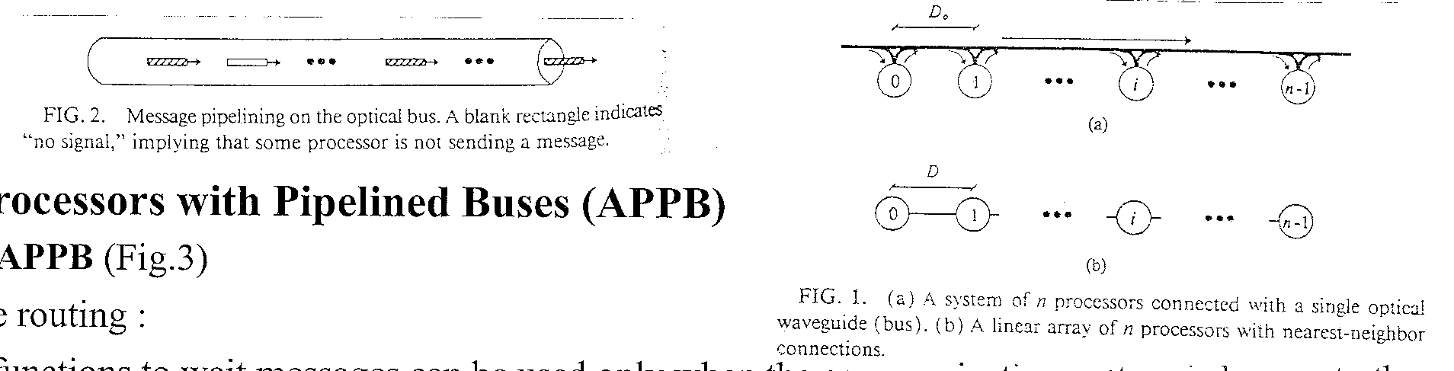

- Array Processors with Pipelined Buses (APPB)
- Linear APPB (Fig.3)
- Message routing :
Control functions to wait messages can be used only when the communication pattern is known to the reciever ( sender is known ). Otherwise, coincident pulse techniques by the detector of the receiver may be used.
ex. wait (i) = i-j
- Embedding : (Fig.4,5)
- Interleaved pipelining : Insert a message into any available slot. This may be accomplished if a node is allowed to place more than one message on the same bus within a bus cycle, but at defferent petit cycles.
Overlapped pipelining : Allow the messages for bus cycle s to be initiated before bus cycle s-1 terminates, as long as message collision does not occur. (Fig.5,6)
ex. kn -> kn/2 + n -> kn/2 + 1 petit cycles

- Two-dimensional APPB (Fig.7)
- Message routing : relay
- Embedding : (Fig.8~11)
efficiency of communication does not depend on the distance between two nodes
<-> It’s desirable that two neighbors in same row or column (alignment condition);
But the nodes in APPB may not be fully used.

- Bandwith analysis
Linear array ~ (Fig.12)
(T_{D} is the propogation time for a signal to travel the distance D, T_{p} is the processing time for a message at the sending and the receiving ends of a communication link. )
pipeline bus : B_{p}= n / [T_{p}+nT_{D}max{1,α}],α=bwc_{g}/D
nearest neighbor connection : B_{a}= n / n(T_{p}+nT_{D})
exclusive access bus : B_{e}= 1 / [T_{p}+nT_{D}]
Pipeline bus is more effective for larger ρ=T_{p}/T_{D} and smallerα=bwc_{g}/D

Created by : Seng-I Yeh
Date : Aug. 31, 1999

